
MEMORANDUM
OF

UNDERSTANDING
Between
Department of Telecommunications

GOVT. OF INDIA

And
Bharat Sanchar Nigam Ltd.
For the Year 2012-13

MEMORANDUM OF UNDERSTANDING

PART-I

VISION / MISSION AND OBJECTIVES

VISION:
- Be the leading telecom service provider in India with global presence
- Create a customer focused organization with excellence in customer care, sales and marketing
- Leverage technology to provide affordable and innovative telecom services / products across customer segments

MISSION:
- Be the leading telecom service provider in India with global presence
  - Generating value for all stakeholders – employees, shareholders, vendors & business associates
  - Maximizing return on existing assets with sustained focus on profitability
  - Becoming the most trusted, preferred and admired telecom brand
  - To explore International markets for Global presence
- Creating a customer focused organization with excellence in sales, marketing and customer care
  - Developing a marketing and sales culture that is responsive to customer needs
  - Excellence in customer service-”friendly, reliable, time bound, convenient and courteous service”
- Leveraging technology to provide affordable and innovative products/services across customer segments
  - Offering differentiated products/services tailored to different service segments
  - Providing reliable telecom services that are value for money
- Providing a conducive work environment with strong focus on performance
  - Attracting talent and keeping them motivated
  - Enhancing employees skills and utilizing them effectively
  - Encouraging and rewarding individual and team/group performance
- Establishing efficient business processes enabled by IT
  - Changing policies and processes to enable transparent, quick and efficient decision making
  - Building effective IT systems and tools

OBJECTIVES:
- To be the Leading Telecom Services provider by achieving higher rate of growth so as to become a profitable enterprise.
- To provide quality and reliable fixed telecom service to our customer and thereby increase customers confidence.
- To provide customer friendly mobile telephone service, with focus on Value added service and data services, of high quality and play a leading role as GSM operator in its area of operation.
- Strategy for:
- Rightsizing the manpower
- Providing greater customer satisfaction
- Contribute towards:
- Broadband customers base in India as envisaged in draft National Telecom Policy 2011.
- Providing broadband connectivity to 2.5 lakhs Village Panchayats as per Government policy
- To leverage the existing infrastructure of BSNL for facilitating implementation of other government programmes and initiatives particularly in the rural areas.
- To look for the opportunity of possible expansion of BSNL footprint globally by exploring international telecom developing markets such as Africa.

PART-II

EXERCISE OF ENHANCED AUTONOMY AND DELEGATION OF POWERS

- BSNL exercises various powers delegated under Mini-Ratna Category-I Enterprise as and when need arises.

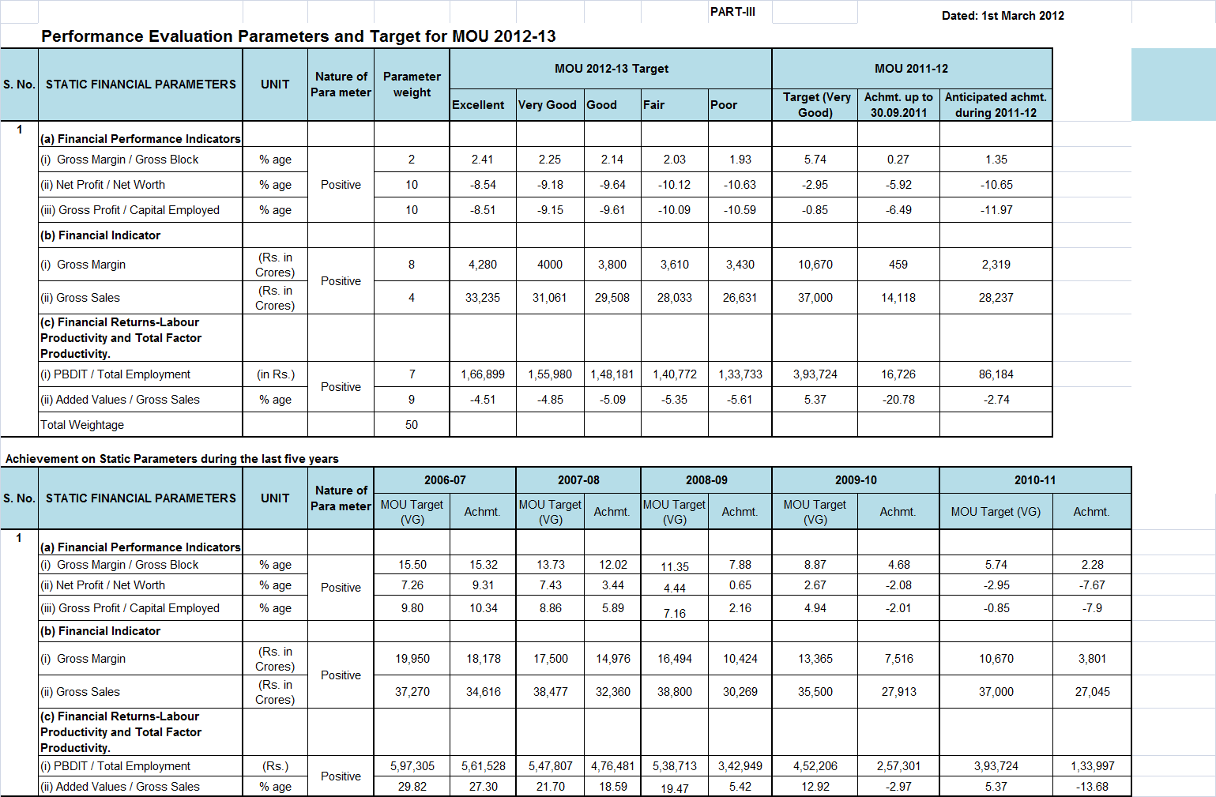

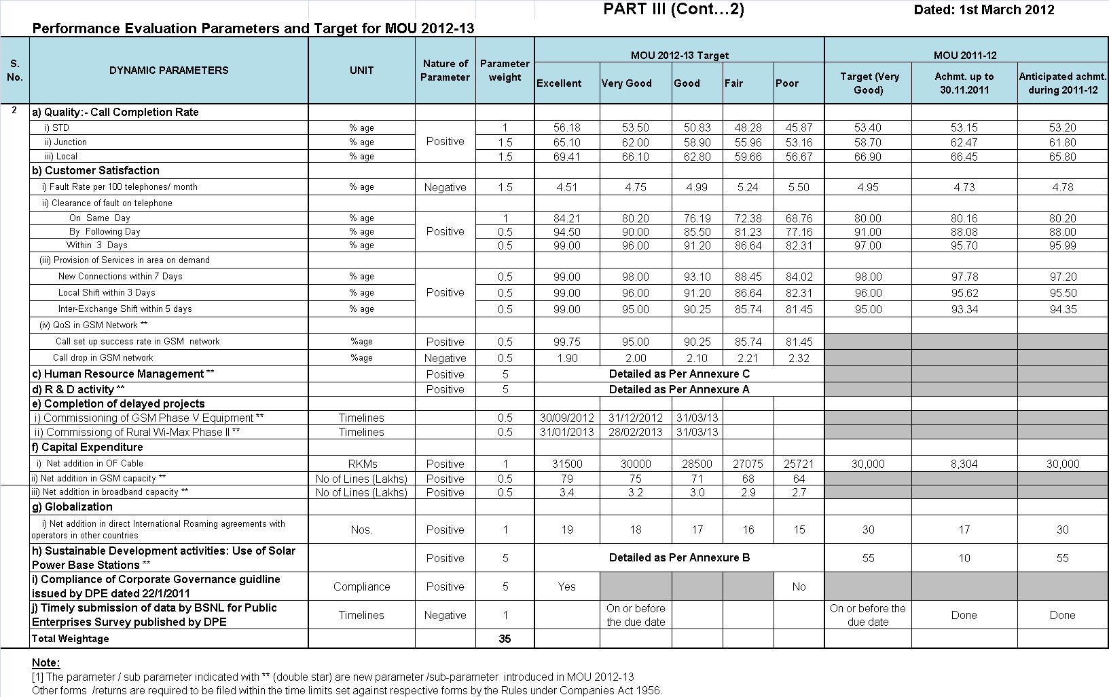
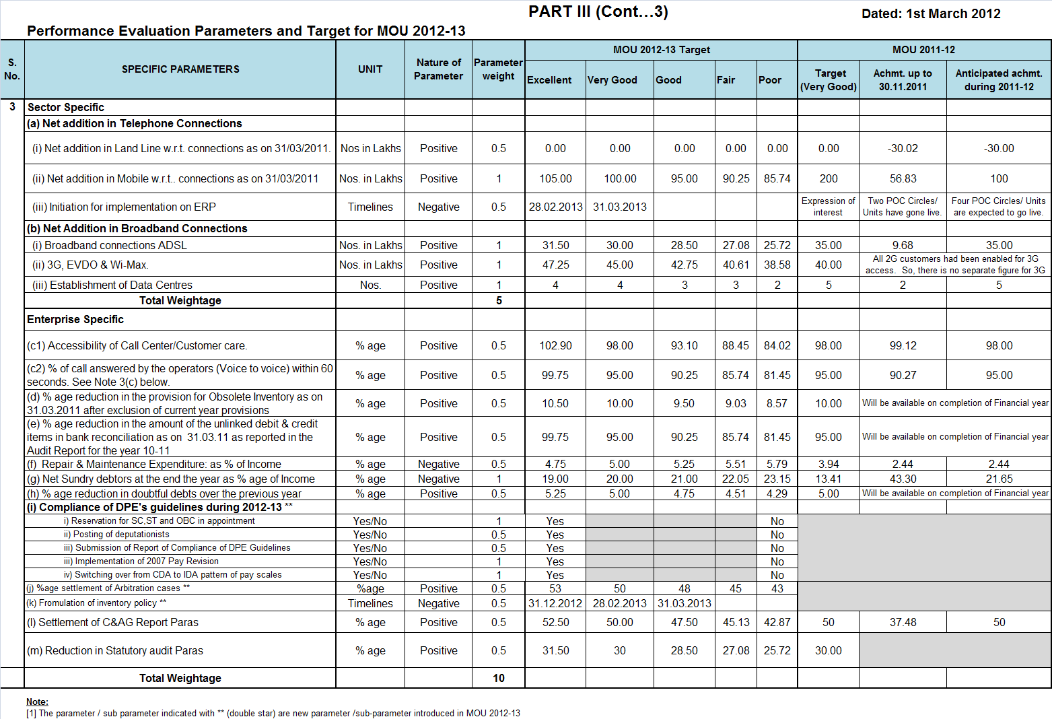
PART-IV
COMMITMENT/ASSISTANCE FROM THE
DEPARTMENT OF TELECOMMUNICATION,
GOVT.OF INDIA

Government shall endeavor to assist BSNL in the following matters:
    - Re-imbursement of deficit on account of commercially non-viable services.
    - Refund of upfront BWA spectrum License fee.
    - Issue of a soft loan which has been requested by BSNL for an actual loan of Rs. 15000 crores for 10 years with a moratorium of 5 years.
    - Center/State governments and PSUs should give priority to BSNL for their telecom service requirement.
    - Pension Contribution is collected on the maximum of the scale in IDA instead of on actual pay drawn which is contrary to the procedure followed in respect of CDA scales.
    - Funding Support for VRS
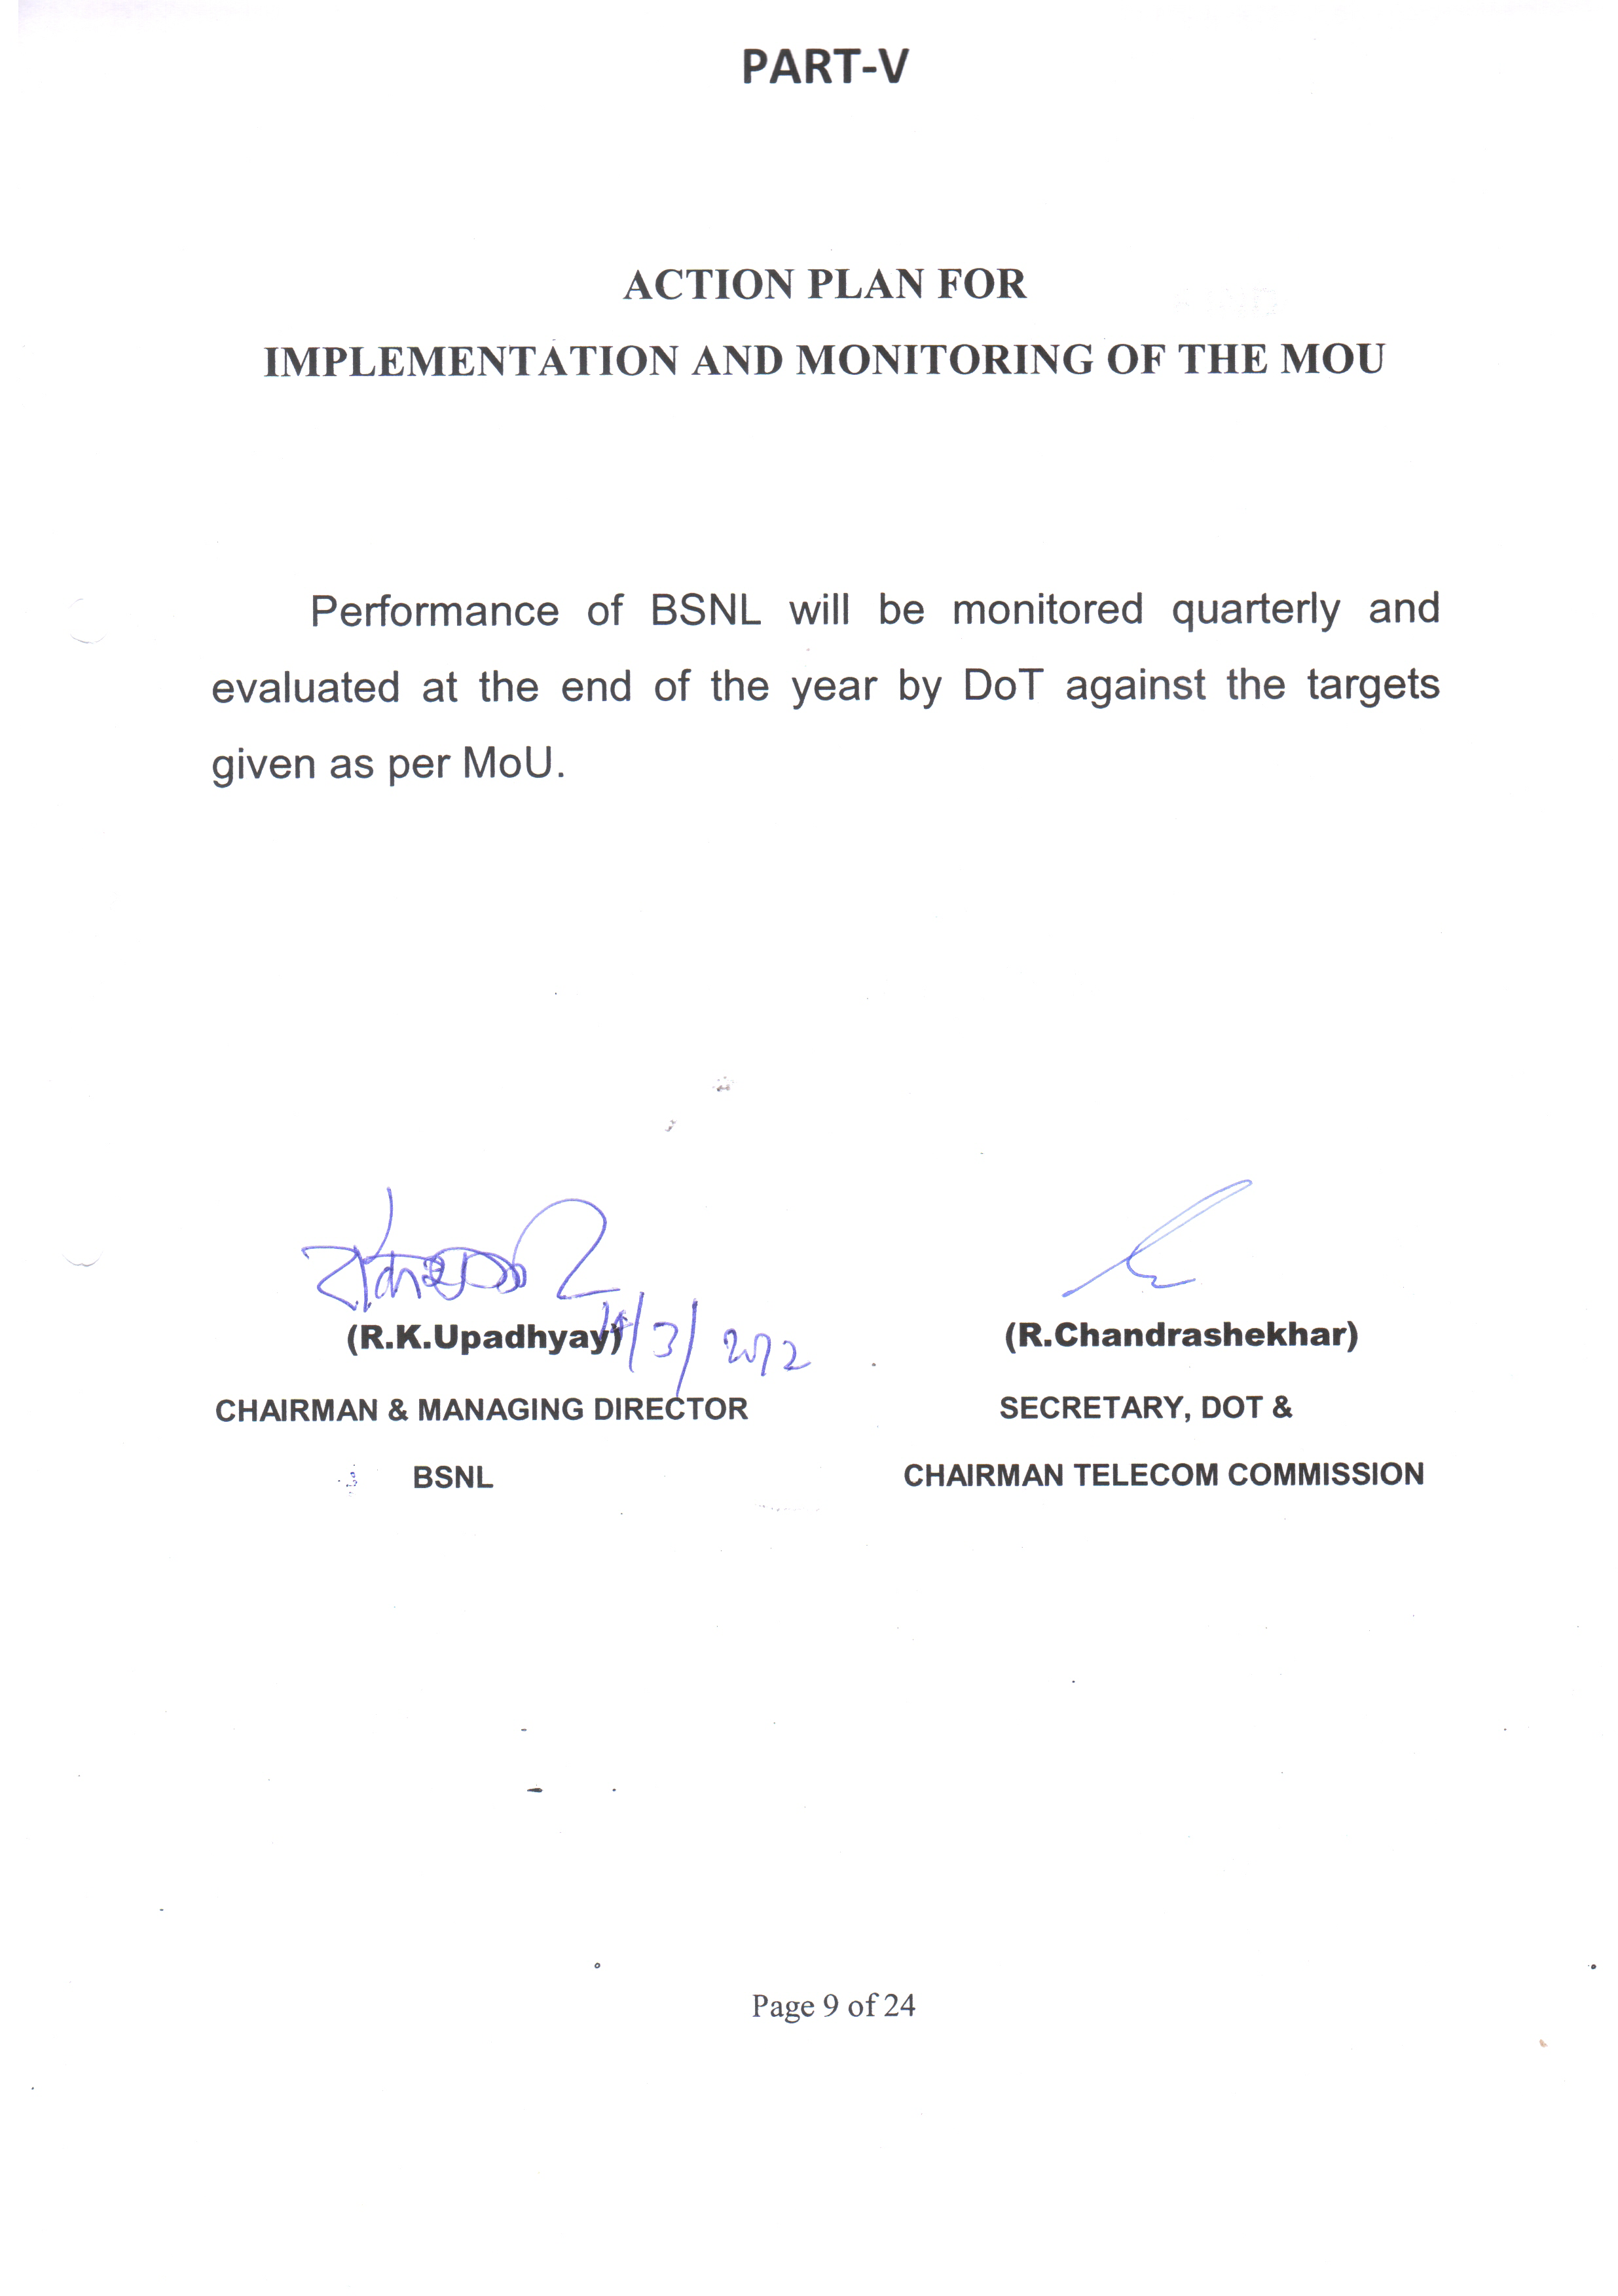
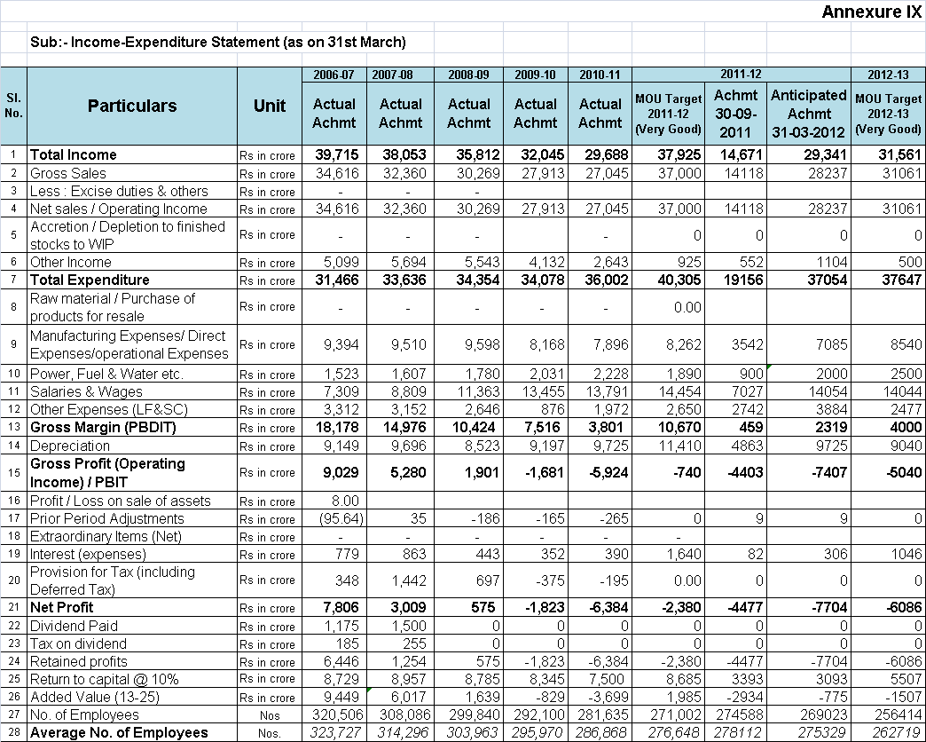
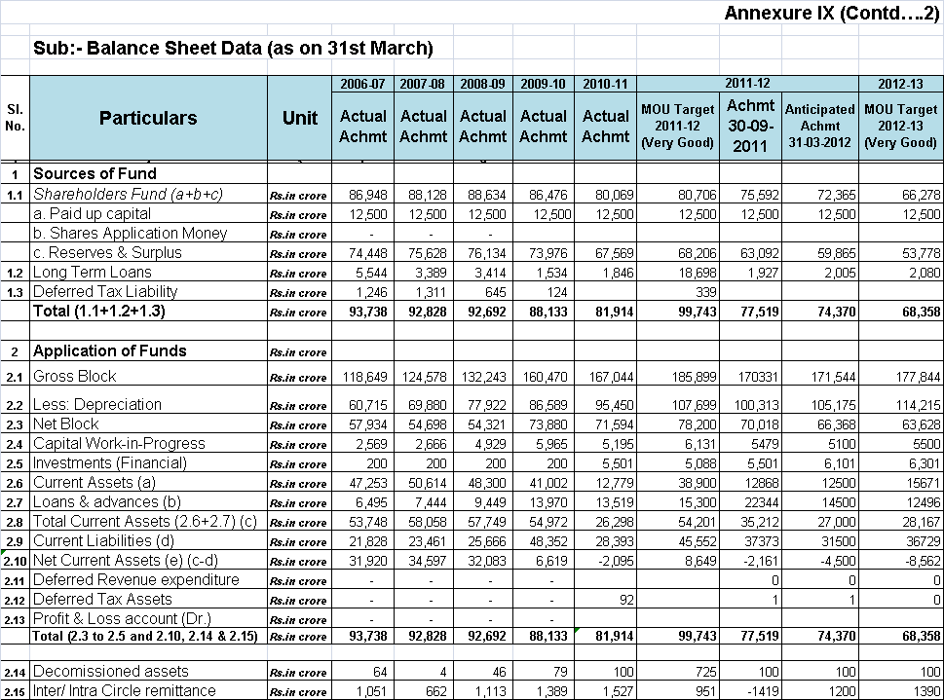
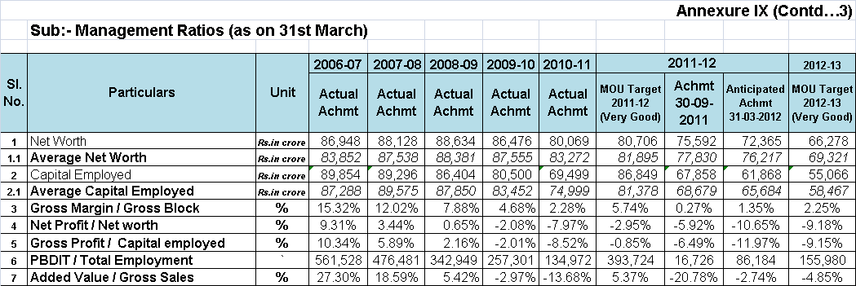
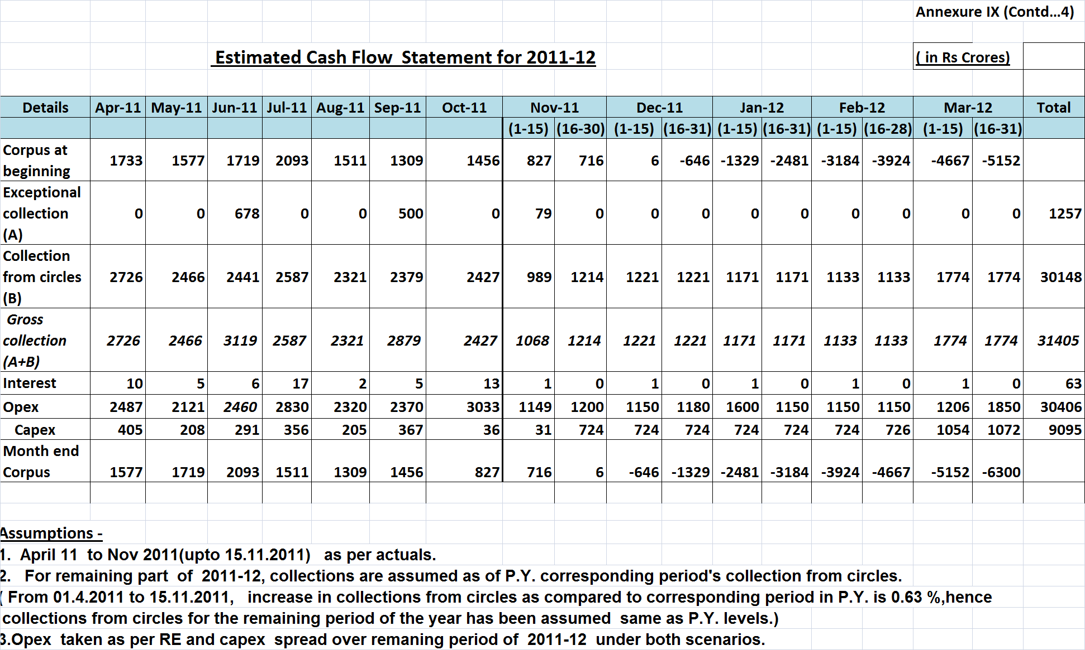
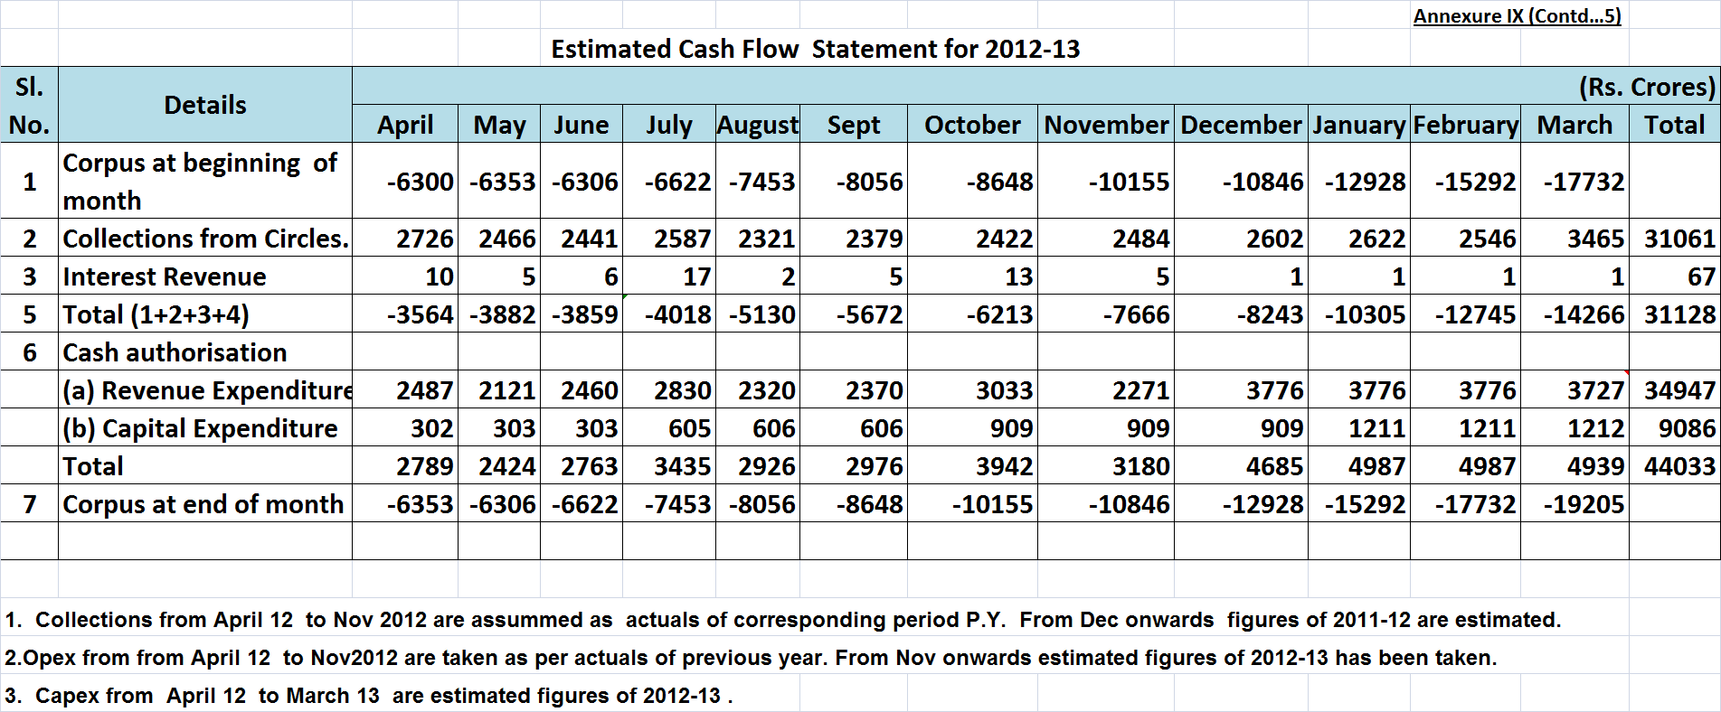
Annexure - A
R&D Performance Target Setting cum Evaluation Template

            - To be Filled and Submitted by each CPSE to the Task Force prior to Annual Target Setting as well as Performance Evaluation of MoU.
            - Circuit Breaker: Any CPSE which has not got its Specific R&D Plan and R&D Budget passed by its Board will automatically be rated as “Poor” in R& D of MoU.
            - CPSE, while submitting self- evaluation report to DPE, will not fill up score allotted for each Table and the Total Score, as the same will be awarded by the Task Force at the time of performance evaluation of the MoU.

Table 1- Mandatory Parameter- Total R& D Expenditure as a percentage of PAT
 |  | Unit | Weightage | Performance Target |  |  |  |  |  |  |  |  | Achievement
 |  |  |  | Excellent |  | V. Good | Good |  |  | Fair |  | Poor
(1) | (2) | (3) | (4) | (5) |  | (6) | (7) |  |  | (8) |  | (9) | (10)
1 | Total R&D Expenditure as % of PAT (Please refer para 3.8(i) of the Guideline). See Note (a) | Rs Crores | 2.5 | 5.25 | 5 |  |  | 4.75 | 4.51 |  | 4.29

Total Score for this Table | 2.5

Score allotted by the Task Force

Note (a): The target is defined as a %age of Profit After Tax (PAT). BSNL has posted a loss of Rs 6384 Cr in 2010-11. In the year 2010-11, the target under R&D budget was fixed at Rs 5 Crores for V.Good Rating. For the Year 2012-13 also, BSNL has proposed a VG Target of R&D budget of Rs 5 Crores which was accepted by the Task Force members in the meeting held on 20.01.2012.

Table 2 - Projects chosen by CPSE
At the time of draft MoU : Every year, CPSEs shall submit R&D projects ( Maharatna & Navratna -Five Projects, Miniratna- I&II and other CPSEs below– Three Projects along with one most important / vital/key Performance Indicator to Task Force at the time of draft MoU. The Task Force will approve the same or add any other R&D projects alongwith performance indicator(s).
At the time of MoU Evaluation : The verification of achievement in respect of approved performance indicator (s) and evaluation / rating of each R&D project will be done by Independent Expert/Research Advisory Committee of CPSE. Such evaluation / rating will be considered / accepted by Task Force during evaluation for allotting MoU score on R&D.
 |  |  |  | Target Value
(1) | (2) | (3) | (4) | (5) | (6) |  | (7) |  | (8) |  | (9) |  | (10)
S. No. | Projects Chosen  (Annexure -I) | Performance Indicator (Annexure-II) | Weightage | Excellent | V. Good |  | Good |  | Fair |  | Poor |  | Actual
2 .1 | Intelligent Optimization tool for Cellular Network | Time Lines | 1 | 31.12.2012  31.12.2012  31.12.2012 |  | 28.02.2013  28.02.2013  28.02.2013 |  | 31.03.2013  31.03.2013  31.03.2013
2.2 | Development of Agropedia | Time lines | 1
2.3 | Multistage IPM in MDF for protection cards | Time Lines | 0.5

Total Score for this Table | 2.5
Score allotted by the Task Force
Total Score on R&D | 5
Total allotted Score for both Tables

Note: BSNL has shortlisted various projects under Telecom Centre of Excellence (TCOE) in coordination with IIT-Kanpur. Three projects have been selected under R&D for MOU 2012-13 which was agreed by the Task Force Members in the meeting held on 20.01.2012.
Annexure - B
SD Performance Target Setting Cum Evaluation Template

      - To be Filled and Submitted by each CPSE to the Task Force prior to Annual Target Setting as well as prior to Performance Evaluation of MoU.
2 Circuit Breaker: Any CPSE which has not got its Specific SD plan and SD Budget passed by its Board or its Designated Committee will automatically be rated as ‘Poor’ in SD of MoU.
3 CPSE, while submitting self-evaluation report to DPE, will not fill up score allotted for each table and the total score, as the same will be awarded by the Task force at the time of performance evaluation of the MoU.
S.No. | Activity
1 | Whether Specific SD Plan and Budget passed by Board or its Designated Committee | Yes / No  No. and Date of Board Resolution
 | 1 | 2
 |  | Yes. The plan has been approved by Ministry of New and Renewable Energy, Govt of India

Table 1. SD Committee details ( )
Board level Designated Committee Name | Chairman of Board level Designated Committee |  | Number of regular meetings held |  | Key decisions during the year
1 | 2 |  | 3 |  | 4
No such committee has been constituted in BSNL.
Total Score for this Table |  | 0.5
Score allotted by the Task Force

Table 2 Total SD Expenditure as a percentage of PAT
*Target Value as % of PAT  (on a five-point scale: Para 6.5.2 of Guidelines) | Total expenditure (Current FY) (Rs lakhs) |  | Profit after tax (Previous FY)  ( Rs lakhs) |  |  | Actual Expenditure as % of PAT
1 | 2 |  | 3 |  |  | 4
See Note (a) below | 1211 (See Note (b) below) |  | See Note (a) below
Total Score for this Table |  | 0.5
Score allotted by the Task Force

* Note: - The projected annual expenditure as % of the PAT for the performance year will be considered as target for the year.

Note (a): The target is defined as a %age of Profit After Tax (PAT) which is not directly applicable as BSNL has posted loss of Rs 6384 Cr in 2010-11. A total of 55 BTS sites are planned to be solar powered in 2011-12 as per MOU 2011-12. The SD project has been undertaken based on the subsidy received from DOT / MNRE. The detail of subsidy received along with cost to BSNL is given below.
All Cost in Rs Lakhs
Sl No | No of Sites | Type | Cost per Site | Total Cost | Subsidy | Agency of Subsidy | Cost to BSNL
1 | 41 | Solar | 22.5 | 922.5 | 830.25 | MNRE | 92.25
2 | 14 | Solar(10)/Hybrid(4) |  | 289 | 257 | DOT | 32
Total | 55 |  |  | 1211.5 | 1087.25 |  | 124.25

Note (b): The previous figure of Rs. 1238 Lac was based upon the estimated cost of 55 Sites @ Rs. 22.5 Lac per site and Rs. 1211 Lac is based on the Awarded amount of 14 no. sites and estimated cost of 41 sites @ Rs. 22.5 lac per site.

Table 3 Projects Chosen by CPSE
Sr. No. | Schedule  A / B | Project / activity  (Please refer Annex-I) | Performance Indicator (Please Refer Annex- II and Para 6.5.3 of Guidelines) |  | Total expenditure on Project / Activity  (Rs lakhs) |  | Duration  S / M / L | Target Set  (on a five-point scale: Para 6.5.3 of Guidelines) | Target Achieved
1 | 2 | 3 | 4 |  | 5 |  | 6 | 7 | 8
1 | A | Energy Efficiency
2 | A | Energy Conservation
3 | A | Renewable energy usage (See Note 1 below) | No. of sites |  | 1350 |  | S | (See Note 1 below)
4 | A/B | Conducting Energy Core group meeting
5 | A/B | Training of Employee
Total Score for this Table |  |  |  | 2.5
Score allotted by the Task Force
Table 4- Evaluation of Projects
    - By Administrator USOF for USO sites
    - By officials of MNRE for Non-USO Sites
No. of projects evaluated by an Independent External Agency/ Expert/ Consultant, etc.

Total Score for this Table | 0.5
Score allotted by the Task Force

Note 1. A total of 60 BTS sites (Very Good Target) are planned to be solar powered in 2012-13, as finalized in the negotiation meeting with Task force members on 20.01.2012. The Excellent target is 63 sites, Good target is 57 sites, Fair Target is 54 sites and Poor Target is 51 sites. The SD project has been undertaken based on the subsidy received from DOT / MNRE. The details of subsidy received along with cost to BSNL is given below.

All Cost in Rs Lakhs
Sl No | No of Sites | Type | Cost per Site | Total Cost | Subsidy | Agency of Subsidy | Cost to BSNL
1 | 60 | Solar | 22.5 | 1350 | 1215 | MNRE | 135

Table 5 - Publication of SD Performance Report

Activity | Yes / No | Mode of SD Report  (If reported, whether a stand-alone SD Report or a part of Annual Report, etc.)
1 | 2 | 3
SD performance Report | Yes | Part of Annual Report
Total Score for this Table |  |  | 0.5
Score allotted by the Task Force

Total Score of all Tables | 5

Total allotted Score for all Tables

Annexure - C

Template for HRM Performance Evaluation under Memorandum of Understanding
Sl. | HRM - PERFORMANCE INDICATORS |  | Measurement Unit | Weightage | Target value under five point scale - Basic Target(Good/ Very Good) -To be filled at the time of submission of draft MoU by CPSE | Actual Performance (To be filled at the time of submission of performance evaluation by CPSE) | Self-Evaluation Score( tobe filled up at the time of submission of performance evaluation by CPSE)
Sl. |  |  | Measurement Unit | Weightage
A | Competency & Leadership Development
 | A1 Compulsory
1 | % actualization of Training Plan & Training Days per employee per year |  | % fulfillment & Days/per employee per year | 10 | 4 mandays / executve and 1 mandays / non-executive.
2 | Developing critical mass of leaders through a system of career planning & development |  | % fulfillment of planned leadership development programmes | 0 | Not planned for this year
3 | Training budget as % of employee cost |  | % of employees cost | 5 | 1
4 | % fulfillment of training plan for Multi-skilling / Skill Upgradation of non-executives |  | % | 5 | 20
 | A2 Optional (Out of below five, one is to be taken in the MOU) |  |  | 5
5 | % of executives covered in 360 degree feedback system against plan | % |  | 5
6 | % of Senior level executives ( HoDs & GMs and above) covered in Assessment & Development Centre | % |  | 5
7 | Training interventions in new/advanced technology - % fulfillment of training plan in new technology | Numbers |  |  | 5000 unique employees
8 | Interventions towards Industry- Academia Interface | Yes/No; details
9 | % fulfillment of Plan for carrying out Competency Mapping of employees | %
 | Total |  |  | 25

Note: All Targets are for Very Good.

B | Performance Management
10 | To ensure implementation of Bell Curve Approach in PMS rating | Yes / No | 5 | Yes
11 | Linkage of Developmental Plan of Executives with Performance Management System | Yes/ No | 5 | Yes
12 | Implementation of PRP linked to PMS | Yes/No; details | 0 | Not planned for this year because company is in loss
 | Total |  | 10

Note: All Targets are for Very Good.

C | Recruitment, Retention & Talent Management
13 | Manpower Rationalization through | % of Employees  % of Employees
13 | - Voluntary retirements | % of Employees  % of Employees | 15 | 15 (See Note 2)
13 | - Redeployment | % of Employees  % of Employees | 5 | 2 (See Note 2)
13 | - Any other | % of Employees  % of Employees
14 | Attrition as % of total employees | % | 5 | 0.5 (See Note 2)
15 | Presence of Mentorship Development Programme - Nos. of Mentors & Mentees | Yes / No ; Numbers | 0 | No (Not planned for this year)
16 | Formulation / Implementation of systems for management of Talent such as - Job rotation system, reward system, sponsoring sr. executives for Advanced Management Programme, growth opportunities etc | Schemes / Initiatives & their details.  See Note [3] | 10 | 1500
 |  |  |  | 150
 | Total |  | 35

Note:
[1] All Targets are for Very Good.
[2] The total Number of Employees as on 31.12.2011 is 2.71 lakhs. The Voluntary retirement is planned for 15% of the Employees which comes to 40,650. The redeployment is planned for 2% of the Employees which comes to 5420. The Attrition is expected for 0.5% of Employees which comes to 1355.
[3] The schemes which are in operation are: (a) Annual employee Excellence / Reward at National / State / District Level and (b) Deputation of top management officers in Advanced management programme

D | Enabling Creativity & Innovation
17 | Nos. of Nominations/entries submitted for National Awards ( PM Shram Awards, Vishwakarma Rashtriya Puraskar) | Nos. of nominations/ entries submitted for national awards | 0 | Not Applicable
18 | Number of suggestions generated per employee per year | Timelines | 2 | Formulation of Scheme by 30.06.2012
19 | % of Quality Circle projects completed against total Quality circle projects undertaken in a year | % fulfillment | 0 | Not planned for this year
 | Total |  | 2
Note: All Targets are for Very Good.

E | Employee Relations & Welfare
20 | Effectiveness of Grievance Redressal system - % of grievances settled vis-à-vis received during the year | % settlement | 10 | 60
21 | Pension, medicare, Yoga classes to reduce stress where the job is stressful, setting up of wellness centre such as Gym etc. | Number of programs/date of implementation of scheme | 10 | 50 programs on Yoga and meditation across training centres countrywide annually
22 | Employee satisfaction survey - ESI measure in % | % | 0 | Not Applicable
23 | Formulation & Implementation of social security scheme | Yes/ No | 0 | No
24 | Number of structured meetings with employees' representatives | Number of meetings | 8 | 500 meetings – National / State / District  (Composite)
 | Total |  | 28
Note: All Targets are for Very Good.

F | HR Branding & Excellence - Indicate achievement in this field for initiatives such as :
25 | Participation in survey conducted by external agencies (Employer of choice, Best employer, Best Place to Work etc.) | Details regarding the initiatives to be given alongwith achievements |  | Not planned for this year
25 | Review/ Revisit/ Re-engineer HR Policy for meeting changing business priorities. |  |  | Not planned for this year
25 | Benchmarking projects undertaken in area of HR |  |  | Not planned for this year
25 | Organization Culture Building initiatives |  |  | Not planned for this year
 | Total |  | 0
 | Grand Total |  | 100
 | NB: Total score out of 100 awarded on HRM to CPSE will be converted into score out of 5 in MoU on pro-rata basis

Annexure- D
Means for Measuring the Performance of Non-Financial Parameters:
The means for measuring the performance of Non-Financial Parameters along with source/origin of information is given below:
Sl.No. | Parameters which are to be measured | Means for measuring the achievement
2(a) | Quality:- Call Completion Rate
 | - STD | Traffic Report generated from the respective exchange is fed in the MIS system by respective SSAs
 | - Junction
 | - Local
2(b) | Customer Satisfaction
 | - Fault Rate per 100 Telephones / month | Data is taken from the respective FRS/Commercial system & fed in the MIS by respective SSAs
 | - Clearance of fault on telephone
 | - Provision of services in area on demand
2(c) | HRD Factor- Training of staff | HRM package as given in CTMS provides staff strength information.
2(d) | Project Implementation
 | - Net Addition in Equipped Capacity  Fixed( Wire line + WLL) | Monthly reports are received from respective SSA/Circles and compiled at Corporate office. CDMA WLL connections may be verified from respective B&CCCs.
 | - Net Addition in Broadband Equipped Capacity | Monitored through NOC by BBNC. Data is provided on a monthly basis & is being cross verified with data obtained from various circles & is then consolidated.
2(e) | Capital Expenditure
 | - Net addition in OF Cable | Monthly reports are received from respective units and compiled at Corporate office.
 | - Net addition in OFC System
2(g) | Sustainable Development activities: Use of Solar Power Base Stations | Uploaded on Google.doc. on Google.com in the enclosed proforma.
2(h) | Compliance of Corporate Governance
 | - Submission of CG Norms Quarterly Returns to the Administrative Ministry on or before due date. | Photocopy of the Quarterly Report relating to respective Quarter, along with the forwarding letter.
 | - Holding of prescribed Minimum number of meetings of the Board & holding of the AGM within the prescribed limit. | Photocopy of the Quarterly Report relating to respective Quarter, along with the forwarding letter & Register of the Directors Attendance in the Board Meetings.
 | - Filing of Annual Financial Statements, Annual Returns & Other prescribed forms with RoC[MCA] on or before due date. | Vouchers showing evidence of filing of the respective reports/returns with the RoC & the copy of respective returns/reports.
3(a) | Net addition in Telephone Connections
 | - Wire line | Zero target.
 | - Mobile | Prepaid subscriber count report will be collected from IN on day to day basis & postpaid figure count will be taken from the offline billing server of Trichy Billing Centre. Total Net connections are arrived at by adding the respective counts & incorporating them in the MIS report.
3(b) | Net addition in Broadband Connections
 | - Broadband connections ADSL | Monitored through NOC by BBNC. Data is provided on a monthly basis & is being cross verified with data obtained from various circles & is then consolidated.
 | (ii) Establishment of Data Centres | Manual.
 | - 3G & WiMax | Prepaid dump is based on IN status of the customer which is captured to the local system. Billing servers generate Postpaid dump & after combining the respective dumps the count is calculated. Measured/monitored through NOC Bangalore.



